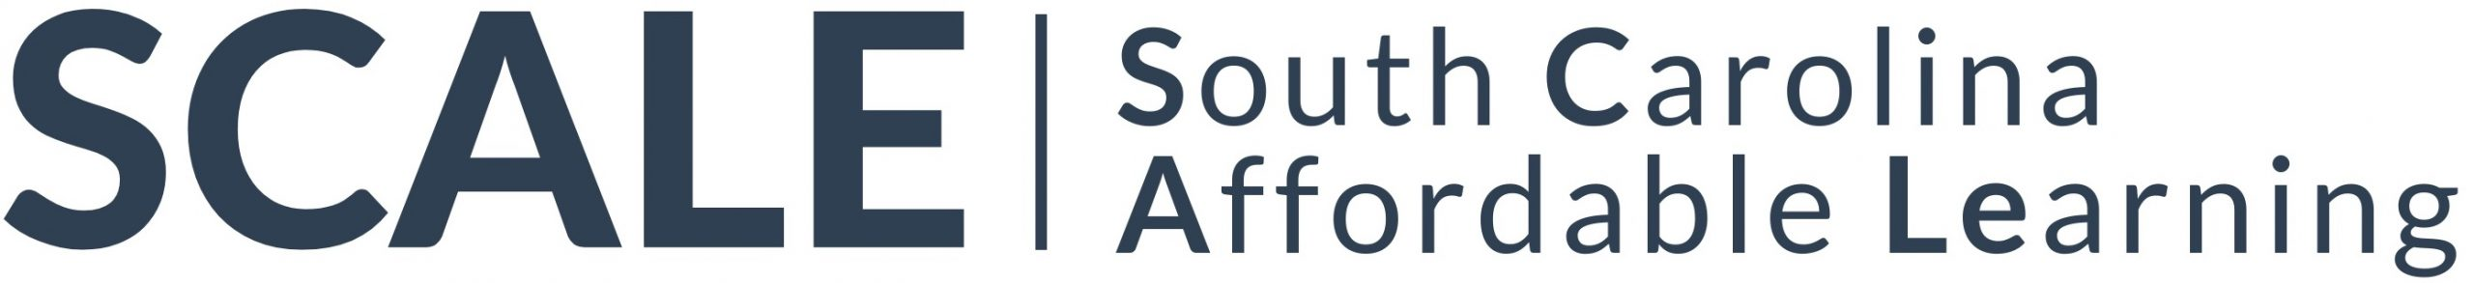

Book Proposal to SCALE, an imprint of Clemson University Press

The proposal is used during peer review, the board approval process, and for initial marketing. It is important that you complete all sections of the proposal. Once you have completed this form, please submit it as a Word document via email to John Morgenstern at jmorgen@clemson.edu.

The SCALE imprint publishes only OER (Open Education Resources). Works in the imprint will all be available open access (free to all) in digital formats and in an affordable print edition. Clemson University Press and PASCAL (Partnership Among South Carolina Academic Libraries), its publishing partner, are nonprofit organizations. If a grant or university subvention is available for your project, or if lab fees might defray the base costs of production, please indicate the prospect when submitting your proposal. The availability of a subvention will have no bearing on editorial decisions, but it may increase the feasibility of your project given the limited resources available for publishing freely available content.

Proposed OER Title

Author’s/Editor’s Details
State your job title(s) and then provide a brief description of your previous publication experience, such as related articles, books, or educational materials.

OER overview
In no more than 500 words, provide a brief description of the book’s subject matter, features planned to enhance student learning (e.g. discussion questions or other activities at the end of each chapter), and intended audience (technical college, undergraduate, graduate).

Contents List with a Detailed Synopsis of Each Section
In no more than 200 words per section, please provide a clear overview of the planned book’s organization. Please explain how each section contributes to learning targets for a typical college/university course on the subject.

Course Adoption Potential
Is the book designed to support a course taught across South Carolina? Multiple courses? Could the book as projected be tailored easily to align with institutional contexts or according to the needs of individual instructors? Approximately how many students across the state are typically enrolled each year in a course that might benefit from your proposed OER? Which courses would be most likely to benefit from your OER (e.g. “Introduction to Chemical Engineering” or “First-Year Composition”)?

Brief Pitch
If you were asked to pitch your OER to colleagues teaching in your subject area, how would you persuade them to adopt your textbook over commercial alternatives? The response should emphasize the pedagogical approach in your text rather than the ethical advantages of a freely available textbook.

List of Instructors and Courses
Please provide a short list of instructors who teach in your subject area or institutions whose programs would be supported by your OER, preferably in South Carolina. The Press may draw on this list for potential peer reviewers, but it will also be essential in determining the potential for impact your OER would have on affordable learning statewide. Please limit your list to no more than 10 instructors or institutions most likely to adopt your OER.

Related Textbooks
Are there other textbooks that cover similar ground? If so, please list the titles, publisher, publication date, and retail price for each of the other textbooks. Is your OER distinct in any way from commercially available textbooks on the market? Are there other OER on the subject or would yours be the first of its kind to be freely available to students? How is your book tailored to support student learning in South Carolina (e.g. are illustrative examples localized)?

Approximate Word Count
How long is your OER? If you prefer, you may estimate the book’s page count instead of its word count.

Illustrations and Figures
Would your book require tables, graphs, charts, photos, line drawings, or other illustrative material? Is it necessary to reproduce illustrations in color, or would black-and-white reproductions suffice? Do you have the required illustrations already, or would you need to acquire them? Please state the number and type of illustrations required for the book.

Permissions
Will the book require any permissions? Is the text original, or will you need to reproduce some of the text from another published source? Do you own the copyright on any illustrations that you intend to include? It will be your responsibility to acquire permissions where necessary, though staff at Clemson University Press can assist you in the process.

Proposed Timeline
How long will it take to finish your manuscript? Is there a date by which the publication would be needed to support a course or program?

If you wish to share a writing sample or pages from a previous edition, please attach them in a separate document.

