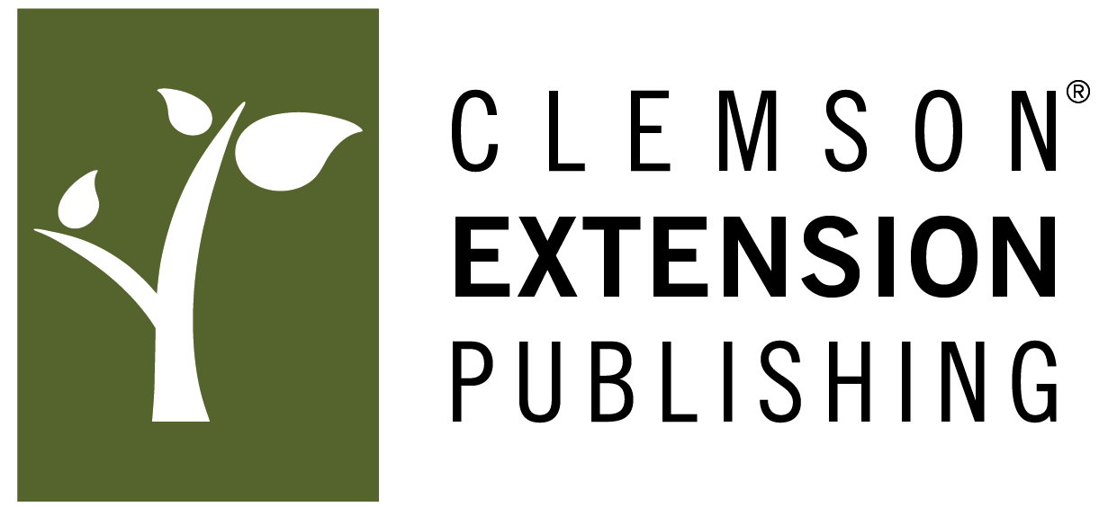

Book Proposal to Clemson Extension Publishing

Please use as much space as necessary to address each of the categories listed below. Once you have completed this form, please submit it as a Word document via email to John Morgenstern at jmorgen@clemson.edu or to Drew Griffin at dbgriff@clemson.edu.

Clemson University Press is a nonprofit publisher. If a grant or university subvention is available for your project, please indicate the prospect on your proposal. The availability of a subvention will have no bearing on editorial decisions but may make feasible special features to enhance your book, such as color images, the reduction of the book’s retail price, or allow us to make special arrangements to provide print copies for programming purposes at reduced rates.

Proposed Book Title

Author’s/Editor’s Details
State your job title(s) and then provide a brief description of your previous publication experience, such as related articles or books published.

Book Synopsis
In no more than 500 words, explain what the book does or argues or the information that it makes available. This synopsis is comparable to the description you’d find on the book’s back cover and on retailers’ sites (e.g. on Amazon). You should articulate your vision for the book or set of books: how will you divide/organize the information?

Contents List with a Detailed Synopsis of Each Chapter
In no more than 200 words per chapter or section, please provide a clear overview of the book’s organization.

Readership
Who will need this book? Who will benefit from the information in it? Would the book be used by an Extension program or a course? Does the book aim to reach a general audience, or is the information essential to provide for a more specialized/focused audience?

Related Books
Are there other books that cover similar ground? If so, please list the titles, publisher, and publication date for each of the other books. How is your book distinct from what’s available on the market? If it’s an updated edition of an existing work, why is a new edition needed?

Approximate Word Count
How long is your book? If you prefer, you may estimate the book’s page count instead of its word count.

Illustrations and Figures
Would your book require tables, graphs, charts, photos, line drawings, or other illustrative material? Is it necessary to reproduce illustrations in color, or would black-and-white reproductions suffice? Do you have the required illustrations already, or would you need to acquire them? Please state the number and type of illustrations required for the book.

Permissions
Will the book require any permissions? Is the text original, or will you need to reproduce some of the text from another published source? Do you own the copyright on any illustrations that you intend to include? It will be your responsibility to acquire permissions where necessary, though staff at Clemson University Press can assist you in the process.

Proposed Timeline
How long will it take to finish your manuscript? Is there a date by which the publication would be needed to support a course or program?

If you wish to share a writing sample or pages from a previous edition, please attach them in a separate document.

